DSC 550-T301 Summer 2025 Data Mining Course Project

Caitie Schrotberger

  - Introduction
In the post-secondary education field, colleges and universities are trying to recruit students to their campuses. Students paying tuition is one of their main sources of income. Other ways they fund their facilities are state or federal funding, alumni contributions, and corporate sponsorships. To continue to grow and maintain their institutions, they have to have students that are successful in obtaining their degrees.
Prospective students look at the programs a university offers and the graduation rates to evaluate if they are going to attend a specific school. If a school or program has poor graduation rates, students perceive that the programs are not successful. To counteract this, universities should look at historical data on graduation rates and model students based on personal demographics and performance in classes to identify those students that may need assistance to get their degrees.
By helping students that may have traits that predispose them to drop out, they can ensure the success of all students and possibly even increase their graduation rates. This will not only make students successful, but encourage donations from alumni, increase corporate sponsorship and ensure that they meet requirements for state and federal funding.
To attempt to model this problem, I obtained a data set from Kaggle that was published on students in Europe that attended undergraduate degree programs from 2008-2019. The data provided demographic, socioeconomic, and economic metrics along with the enrollment information for the students. It has a target variable with three categorical options: drop out, enrolled, and graduate.

  - Milestone Summary
Exploratory Data Analysis
After obtaining the data set, I proceeded with exploratory data analysis (EDA). The raw data held 4,424 rows in 35 columns. I removed any rows with the target category of enrolled because those would be noise in a model as they desired target of graduate or drop out has not been obtained. From there visuals to review the data and understand where further data preparation might be needed.
The first was the number of students by target variable and marital status.
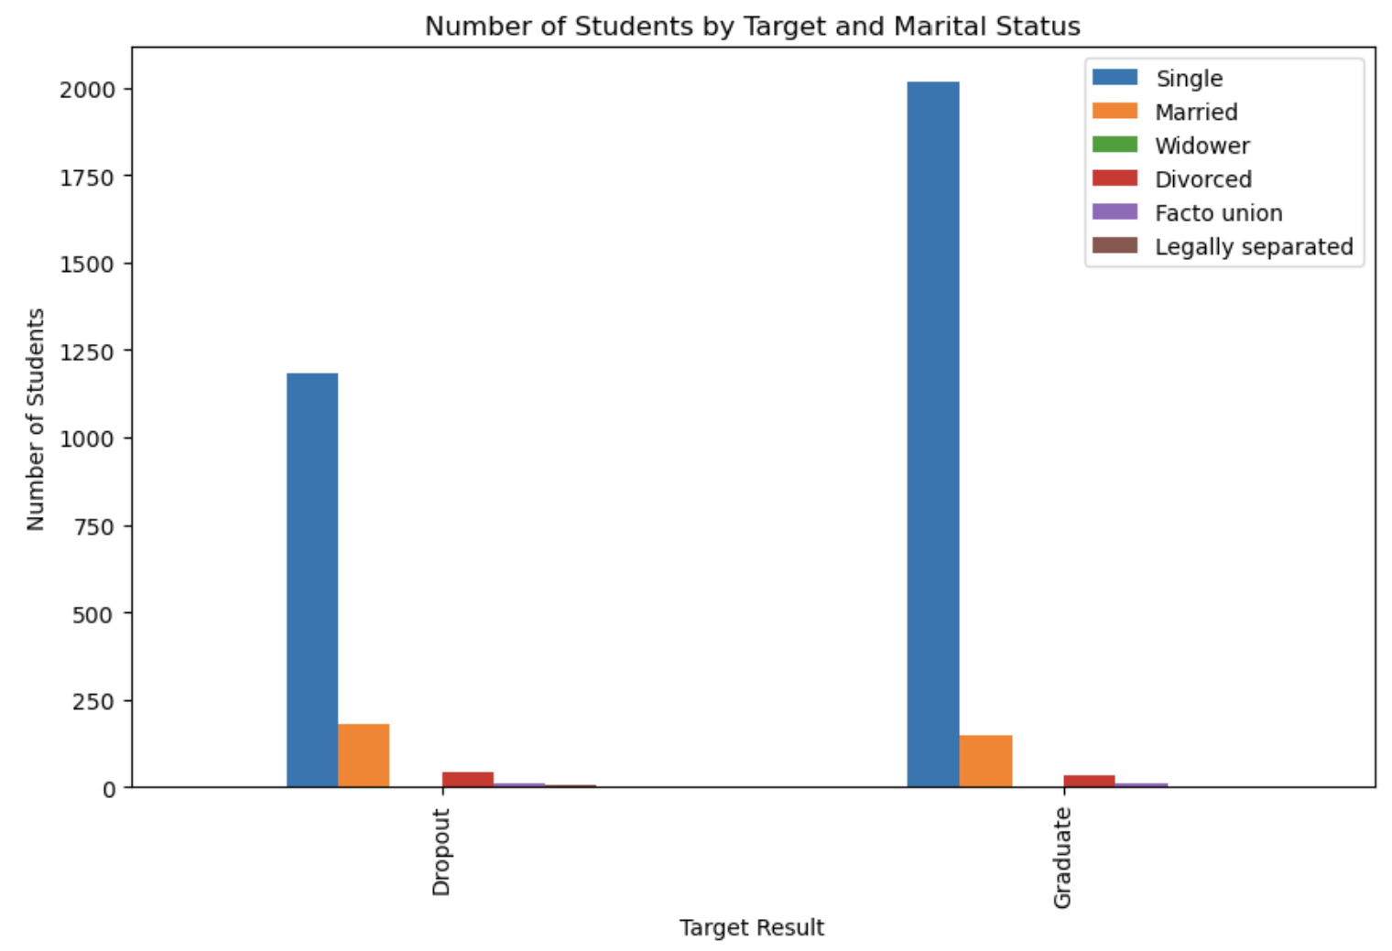
Based on this image, it shows the majority of students are single, with a greater proportion of those that graduate being single.
Second, I looked at the distribution of students by target variable and degree program. 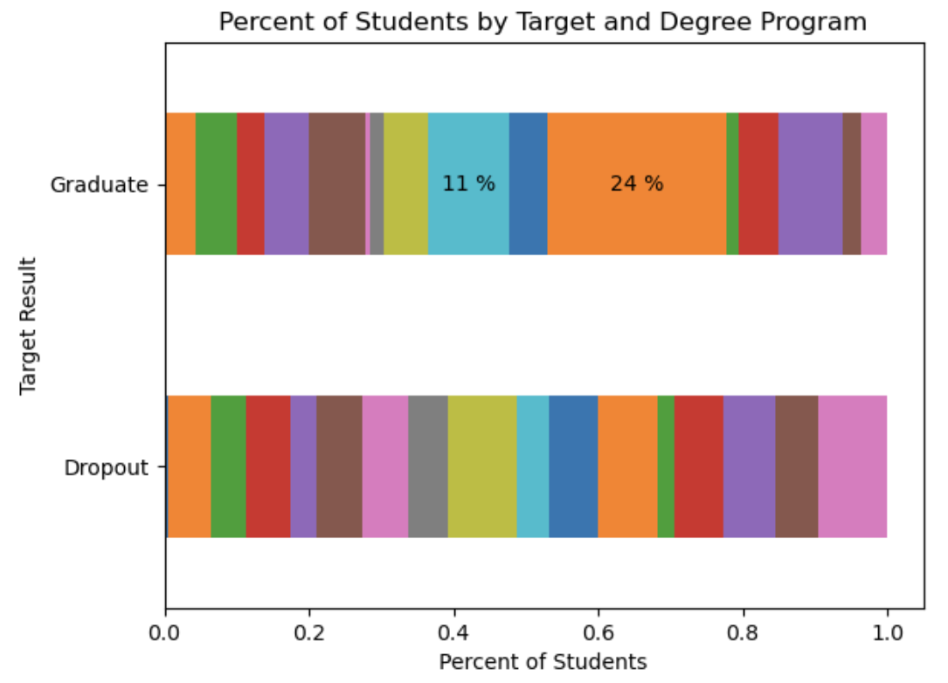
The degree programs with the highest number of students overall are nursing (666 students), with the second being social service (313 students). For those students that graduate, there is a higher proportion of students in the nursing and social service programs. The drop out students have an even distribution among the programs.

Third, to evaluate age I looked at the cumulative distribution of age at enrollment by target variable.
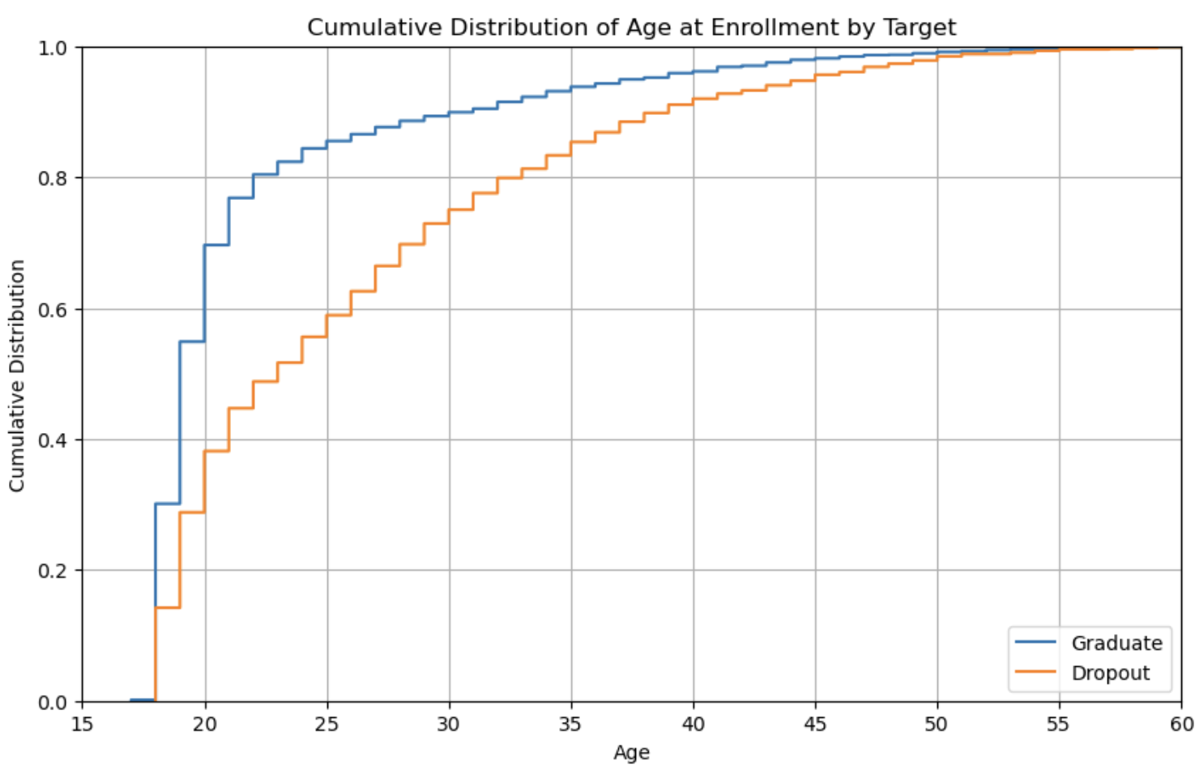
This graphic shows that the younger a student enrolls in college the more likely they are to graduate. Those that graduate have a very steep climb to 80% of the total graduating students by age 23. For those that drop out, 80% of the students are age 33 or younger. The distribution is more curved for the drop out students, meaning the distribution of those that drop out is more evenly distributed.

Fourth, I evaluated the target variable based on the highest education level the student’s mother obtained.
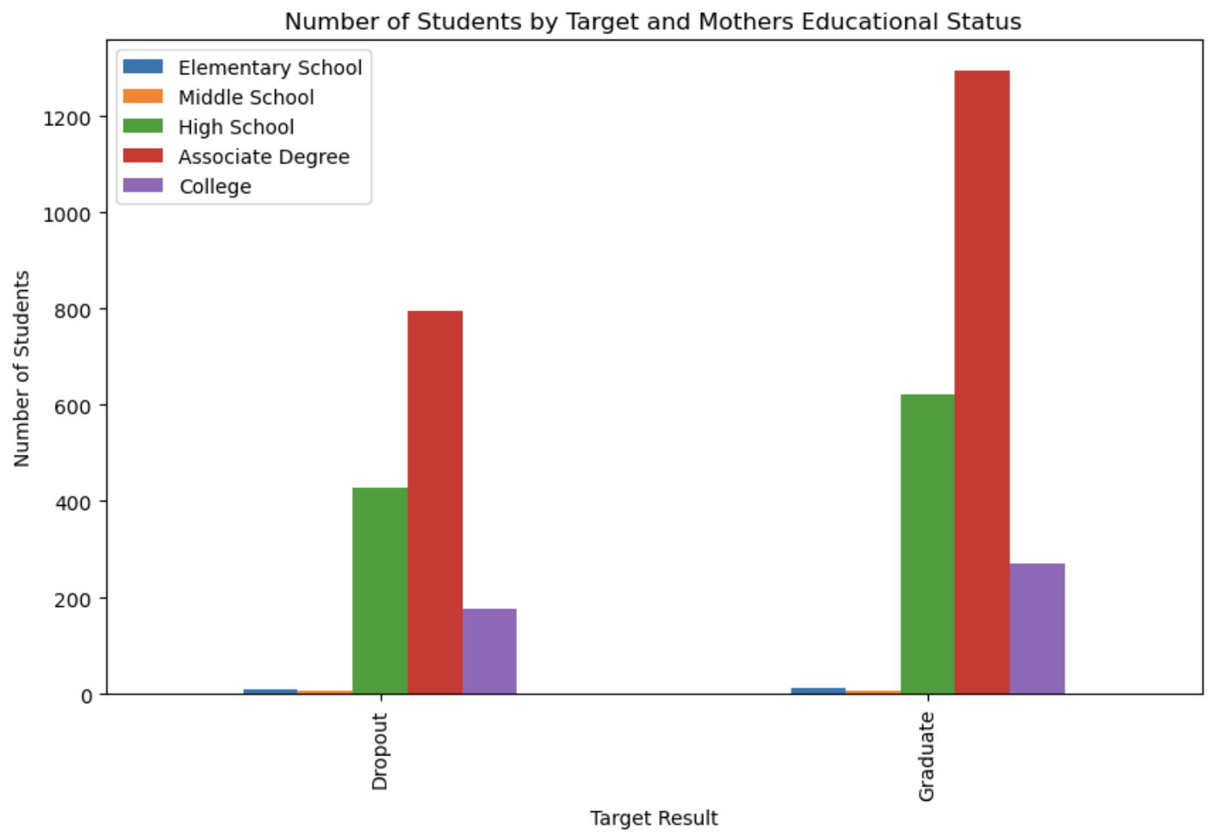
The target variable has similar distributions based on the mother’s education level. Overall, a greater distribution of students had mothers with an associate degree. Those that graduate have 70.9% of mothers with post-secondary education (associates degree or higher). For those that drop out, only 68.5% of the mothers had post-secondary education.
For the final visual, the father’s education status was evaluated.
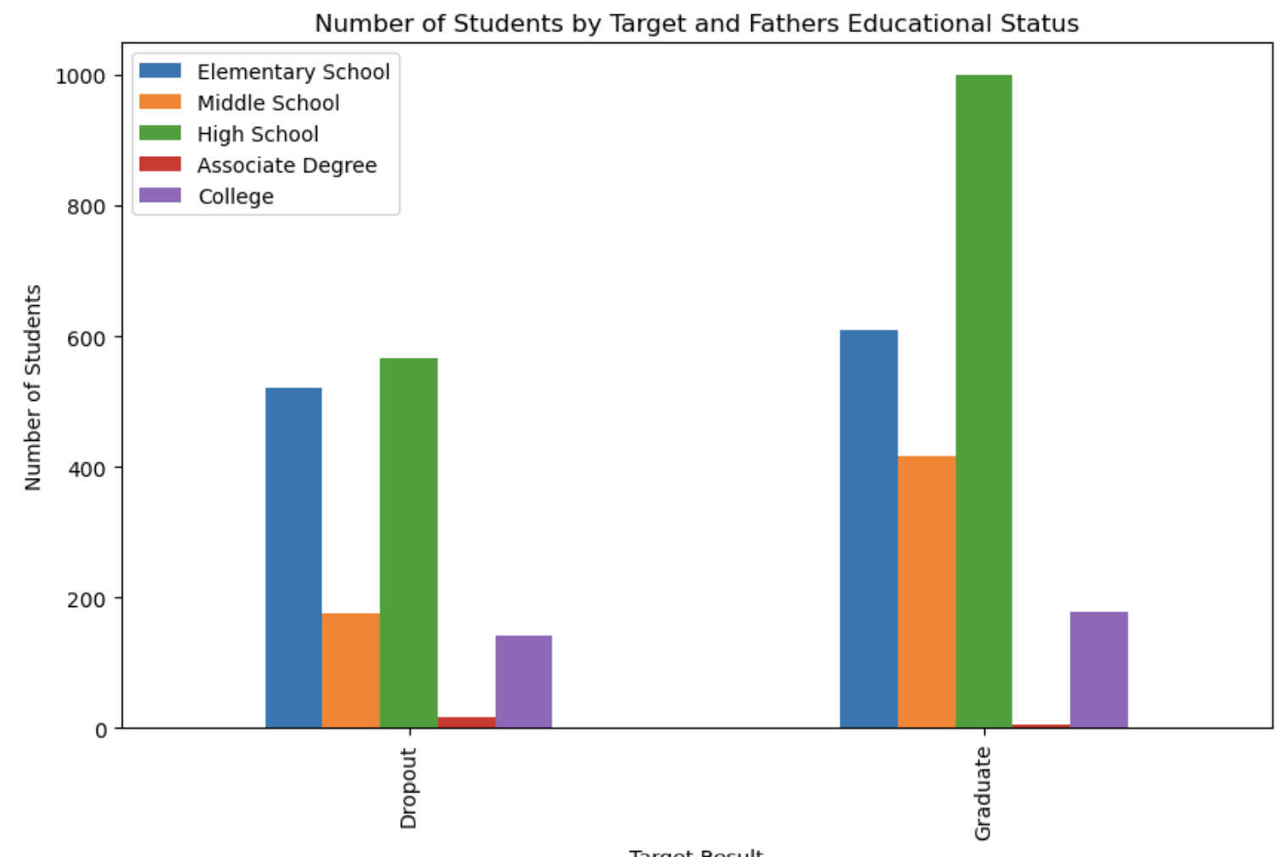
The visuals between the mother and father’s educational status are very different. While overall, 70% of mothers had some post-secondary education but only 9.4% of fathers had that level of education. What is even more interesting is that of those that graduate 8.3% of fathers had post-secondary education compared to 11.1% of those that drop out. The target variable with the greater rate switches between mother and father. For those that graduate, having a father with post-secondary education does not help them.

Data Preparation
There were several data preparation steps that were applied to the data after the EDA was complete.
- I changed the target variable from text to a 1 or 0 value for Graduate or Dropout.
- Column names were updated to remove the ‘ symbol and shorten the length.
- Summary statistics were run on the numerical fields and based on those values rows where there were no enrolled units for first semester were removed.
- Several of the columns had numerical codes for values. To be able to interpret them better functions were made to convert the values from numbers to text as they were not numerically related.
  - A function was created to group the 34 mother and father qualification (educational background) into 5 summary groups: elementary, middle school, high school, associate, college, and other.
  - A function was created to replace 0/1 with no/yes.
  - A function was made to convert the numerical values for gender to text.
  - A function was made to convert the numerical values for attendance to text.
  - A function was made to convert the numerical values for marital status to text.
  - A function was made to convert the numerical values for nationality to text.
  - A function was made to convert the numerical values for previous qualifications course to text.
  - A function was made to convert the numerical values for occupation to text.
- Removed Application Mode as there was no dictionary to go with the values
- Removed Application Order because the order in which they apply for classes could be influenced by other factors (such as when a class is available and fits into their schedule).
- Dummy variables were created for all categorical fields. The conversion of the numerical values within the columns was especially valuable here are then the dummy variables had names that made sense and did not require the user to lookup values.
Model building and evaluation
Three models were identified to be a potentially good fit based on the guidelines for using the model. Those selected were KNN Nearest Neighbors, Logistic Regression, and Decision Tree Classifier. All of these models are ideal for predicting a binary outcome of true/false – so in this case did someone graduate or not? The data set was split into training and test sets at a rate of 80% to 20% of the rows.
The best number of KNN Neighbors (KNN) was 14 and that was used to create the model. The model was made on the training set and used on the test set as well. Accuracy, RMSE, R², and MAE were run on both predictions.
For Logistic Regression (LR), a MinMax scalers was used the training and test models evaluated with confusion matrices, precision, recall, f1, and a receiver operating characteristic (ROC) visualization.
The Decision Tree Classifier (DT) was run and evaluated with a confusion matrix and accuracy. The X2-statistic was used to pick the five best features from the data from the original 97. The top five variables are curricular unites 2nd semester (approved), curricular unites 2nd semester (graded), debtor=yes, Tuition fees up to date=no, scholarship holder=yes.
Finally, a pipeline was built to run all three models at the same time to compare them. The Logistic Regression model was able to run without the scaler. Accuracy, a confusion matrix, precision, recall, F1, and an ROC curve were calculated on the best fit model.
  - Conclusion
The results of the pipeline run showed that logistic regression was the best model for this data set. Below is a table with the model types, the data set the scores are from, and the many evaluation metrics:
Model | Accuracy | RMSE | R2 | MAE | Confusion Matrix | Precision | Recall | F1
KNN - Training | 83% | 0.41 | 0.31 | 0.165
KNN - Test | 80% | 0.45 | 0.12 | 0.203
LR – Test | 79.9% |  |  |  | 148, 104,  36, 408 | 83-91% | 90-95% | 88-92%
DT - Training |  |  |  |  | 211, 41, 69, 375
Pipeline: LR Test | 93% |  |  |  | 218, 34, 12, 431 | 95-99% | 97-99% | 95-99%

Based on these values, the pipeline run logistic regression model performs the best. It has the highest accuracy and best confusion matrix. Additionally, when comparing the two logistic regression models the pipeline run also has the best precision, recall and F1 scores.
After peer review, this model could be deployed to the same schools as the data was obtained from in Europe. Based on the economic and societal changes after the 2020 pandemic it would be good to obtain new data and validate the model is still accurate.
It would also be good to obtain data from the US schools to see if this model would apply as well or if a new one would need to be made. Comparing the results between the two countries’ post-secondary education institutions would be very intriguing.
Overall, I think a model like this would be beneficial to any school to help identify those that may need help remaining successful, with the ultimate goal of graduating.

